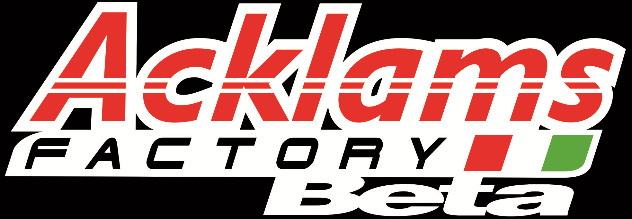

North Riding Enduro Club.

The MichelinWhite Horse Enduro
Supported by Michelin & Acklams Beta
8th September 2019 Permit No. ACU55471

Part of the “ Northern Enduro Championship”

SUPPLEMENTARY REGULATIONS
ANNOUNCEMENT - This is a “open” event for solo motorcycles, held under the National Sporting Code and Enduro standing regulations of the Auto Cycle Union, together with these supplementary regulations along with the "Final Instructions” which will be issued.
BASIC INSURANCE

OFFICIALS
Centre Stewards – John Pullan Club Steward – TBA
Clerk of Course – Andy Cooke Acu 5687 Event Director - Tim Gilbank Acu 5772
Machine Examiner – Stuart Jerram Chief Marshal –Jon Lappin
Forest Saftey Officer – TBA Liason Officer- Paul Mason
Secretary of the meeting – Andrew Cooke NREC 21 St John`s Walk Harrogate North Yorkshire HG1 3AJ
Tel 07818672894
Please note this event runs under Basic ACU insurance
The Insurance cover for this event is “Basic”, there is no Personal Accident cover for Competitors and Liability cover in respect of any claim made by third parties is limited
To £10 million and £5 million for Medical Mal-practice. Competitors are strongly advised to make their own arrangements .

LOCATION - Will be at Boltby Forest approx 5 miles East of Thirsk. Signed from A170 Thirsk to Scarborough road. Start area at High Paradise farm with camping available payable to land owner. There is a one-way system in place for event traffic.
THE START - Will be at 10.00 am, with 3 or 4 riders setting off every minute.
THE ROUTE - The course will consist of forest going, firebreaks and fire roads. The lap length will be 18 miles. (approx) SPECIAL TEST - There will be 1 special test per lap, of a cross-country nature, (untimed on the first lap). RE-FUELLING - Must only take place in the designated area (between the green flags). Crews must provide a fire extinguisher and environmental mat. No smoking in this area.

TIME CHECKS - These will be marked with white flags 200 metres before the check and yellow flags 20 metres
Before the check (do not cross the yellow flags before your designated time).

BLUE TAPED AREAS - These restricted speed areas are there for safety and have a compulsory walking pace speed limit. NONE COMPLIANCE WILL RESULT IN DISQUALIFICATION

LICENCES - Competition Licence number must be provided on application, and presented at Signing on. Day licences are available, if required this must be specified on Entry Form.
SIGNING ON – Will commence from 8.00 am. All riders and marshals must sign on at event control. Worked out times can be purchased for £1 with all proceeds going towards the NREC ISDE team.

MACHINE EXAMINATIONS - Lights must be fitted, No MX bikes! Will take place between 08.15 and 09.30 hrs, you must have your machine in the park ferme by 09.35 Riders only permitted in the Park Ferme. Your machine will be checked for the usual including noise level. It is your responsibility to ensure you comply with the Noise Regulations. Numbers and plates must be fitted to the front and both sides and use correct colours and backgrounds (most of all readable.) We usally provide your No`s.

EVENT BRIEFING- at 9.45am there will be an event briefing when important safety information will be given out. All riders’ crew and public attending are required to attend
MARSHALLS – Please follow the instructions of marshals they are there for your safety!
CATERING – Will be available at High Paradise Tea Rooms adjacent to start field.
LITTER – Please take all litter home with you. Also goggle Roll offs can be used but Tear offs are not permitted they do not degrade and cause hazard to wild animals.

ENTRIES - Are open to members of clubs affiliated to the Auto Cycle Union. Entry fees will not be refunded, unless entry is refused or the event is abandoned (£5 may be retained). All entries to be on an official entry form together with the appropriate fee £60 and 2 S.A.E.'s to the secretary of the meeting (see above) by no later than 23rd September or by online entry. Entries will be limited, no a first come first served basis, with fully completed entry form and cheque made payable to "North Riding Enduro Club." Either 2 stamped & addressed envelopes (9X4 min size) or e-mail address on entry form OTHERWISE NO ENTRY. You can opt to have your Entry Confirmation and Final instructions sent by e-mail. Just put it on your entry form and don’t bother with envelopes. Beware - Make sure you legibly write the correct address down.Better still enter ONLINE, via web site,

Thank you- for supporting our event, to the Forest Enterprise and to all marshals for giving up their day to help you.
Also thanks to Michelin, Acklams Beta, MRS, Eurotek, Graham Charlton Motocyclesand High Paradise Farm.

